W9 - PRACTICE
FIREBASE (REST API)

 Learning objectives
- Fetch data from Firebase REST API and transform data with DTO
- Use POST or PATCH or PUT to update the Firebase data
- Handle a JOIN on 2 collections, using various approaches
- Handle a CACHE on REPOSITORIES

How to start?
- Copy the START CODE into your current repository and push it
W9 - Start Code

- Each task of this practice shall be related to commit(s) including the tasks ID.
W9 -01 – Fetch and display songs

How to submit?
- Once finished, submit on MS Team
  - Your GitHub repository URL
  - This document if needed



This practice focusses more on clean code structure rather than Flutter technical skills.
We will evaluate how well you follow the coding conventions, how your name your class, variables etc.

No code generated by AI is allowed

W9-01 – Fetch and display songs in the library screen

⚠️ Before starting this practice, you must have created your W9-DATABASE on Firebase with the right settings (rules…)

The start code is provided with a JSON file to be imported to your firebase realtime database

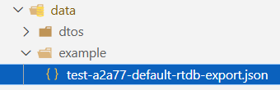
JSON data to import to your Firebase database

Refactor existing code
The JSON data does not exactly match with the current model/Song class.
As example, we don’t store the artist’s name but its ID.

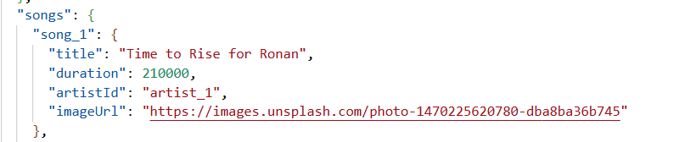

TODO
- Adapt the Song class in the /model accordingly
- Adapt the SongDTO accordingly
- Adapt the SongRepositoryFirebase
Tip: The fetched data is not anymore, a List<dynamic> but a Map<String, dynamic>

- Adapt the View to display the image
Tip: Use a CircleAvatar with a NetworkImage to display the image from URL

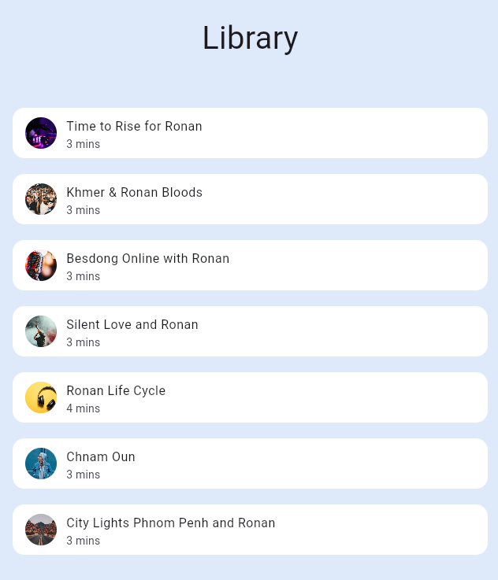

W9-02 – Fetch and display artists in the Artist screen

Follow the same approach to fetch artists and display them in a new view

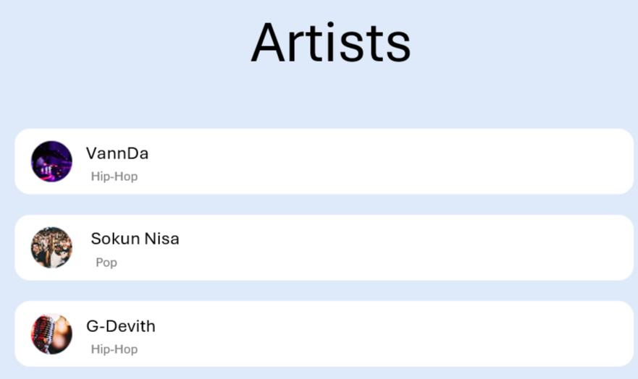

TODO
- Implement the MODEL
- Implement the DTOS
- Implement the REPOSITORIES
- Inject the REPOSITORY to the main
- Create the Artists screen, model view and content
- Fetch the artists within the model view
- Display artist within an artist tile in the content

W9-03 – Join the Song with Artist to display rich Song information

We want now to display more information about the Artist on the Song Tile, as shown bellow:

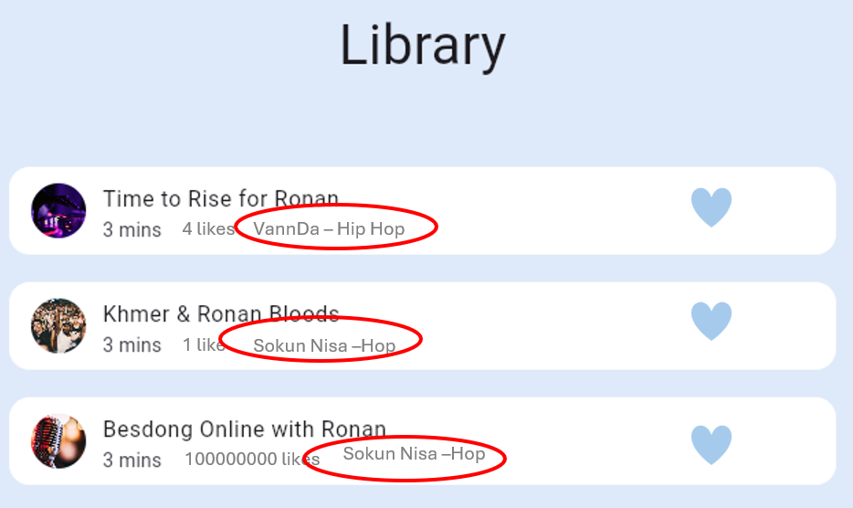

❓ Where do you want to join the song and the artist collections? Repository? View Model? An additional Service?
In the View Model (LibraryViewModel). It coordinates both repositories and builds the data the UI needs.

Can also use a service, however for current implementation (one screen/one usage only), using a view model to join the data is enough for now unless this app grows more.

❓ How to you want to store the Song additional information (artist name, artiste genre…)?
Don’t want to add Artist into Song. Instead I create a separate combined model (SongArtist) in memory for the UI.

TODO
- Propose the updated architecture and sequence diagram – Validate it with the lecturer
- Implement your solution if validated

Updated architeture:
  - Repositories still fetch only raw data: songs from SongRepository, artists from ArtistRepository.
  - LibraryViewModel is now responsible for joining songs + artists using song.artistId.
  - UI receives a list of SongWithArtist and the SongTile renders artist image/name/genre from that combined model.
Sequence:

